

**Report**

**on**

**"Design Thinking"**

**Held on 11th March, 2025**

**Organized by**

**YI Electoral Council, Poornima University**

**Session 2024-2025**

**Dean of Faculty Coordinator of Event**

**Dr. Rakesh Gupta Mr. Karan Singh**

**&**

**Ms. Sani Jain**



**INDEX**

**S. No. Content**

1. **NOTICE/CIRCULAR OF THE EVENT**
2. **OBJECTIVE(S) OF THE EVENT**
3. **COMPLETE REPOR**
4. **GEO-TAGGED PHOTO GRAPHS**



**OBJECTIVES OF THE EVENT**

1. **Encourage Innovation:** Foster a culture of creativity and innovation through design thinking principles.
2. **Brainstorming Practice:** Help students practice structured brainstorming techniques to generate fresh, impactful ideas..
3. **Collaborative Ideation:** Promote teamwork and knowledge sharing to combine diverse perspectives and strengthen ideas.
4. **Prototype Development:** Guide students in transforming their ideas into tangible prototypes or concept models..
5. **Critical Thinking & Analysis:** Encourage students to critically assess real-world healthcare issues and prioritize impactful solutions.
6. **Real-World Impact:** Equip students with the mindset and skills to turn innovative concepts into practical, scalable solutions
7. **Design Thinking Tools & Techniques:** Introduce students to essential design thinking tools like empathy maps, journey mapping, and ideation frameworks.
8. **Presentation & Communication:** Help students articulate their solutions effectively through storytelling and structured presentations.
9. **Inspiration for Future Projects:** Motivate students to continue exploring innovation and technology to solve societal challenges beyond the workshop

**COMPLETE REPORT**

The workshop aimed to equip participants with problem-solving skills by immersing them in real-life scenarios. Students were divided into groups of five, where one student acted as a rural healthcare consumer, sharing hypothetical or research-based issues like lack of medical infrastructure, limited access to doctors, or unavailability of medicines. The remaining group members engaged in deep discussions, asking thoughtful questions to uncover the root causes of these problems.

The participants followed the design thinking framework — **Empathize, Define, Ideate, Prototype, and Test** — to generate and refine their ideas. The goal was to develop solutions that were **desirable** (solving genuine user needs), **feasible** (technologically achievable), and **viable** (sustainable and cost-effective). Students brainstormed ideas such as mobile health clinics, telemedicine platforms, and affordable diagnostic tools. They then collaborated to evaluate and refine their concepts, considering local resources, government policies, and practical implementation strategies.

By the end of the workshop, each group presented their final solution, explaining its impact and potential for scalability. The workshop not only encouraged innovative thinking but also highlighted the importance of empathy and community-driven design. It successfully nurtured teamwork, critical analysis, and a user-first mindset, empowering students to become future innovators capable of solving complex societal problems through design thinking. The experience left participants motivated to explore more ways technology and creativity can improve lives in underserved communities.

**GEO-TAGGED PHOTOGRAPHS**

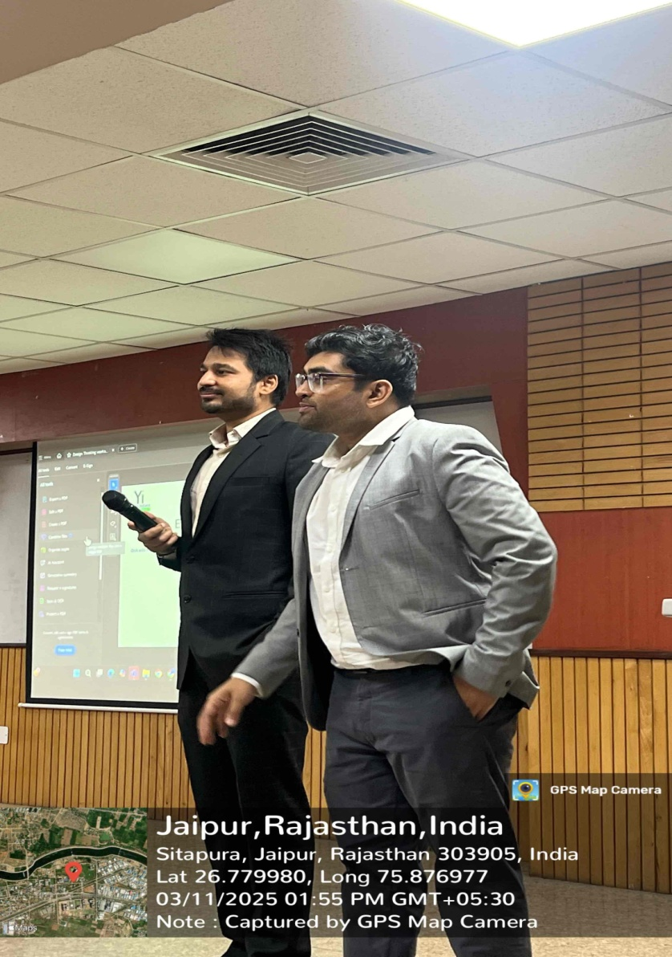

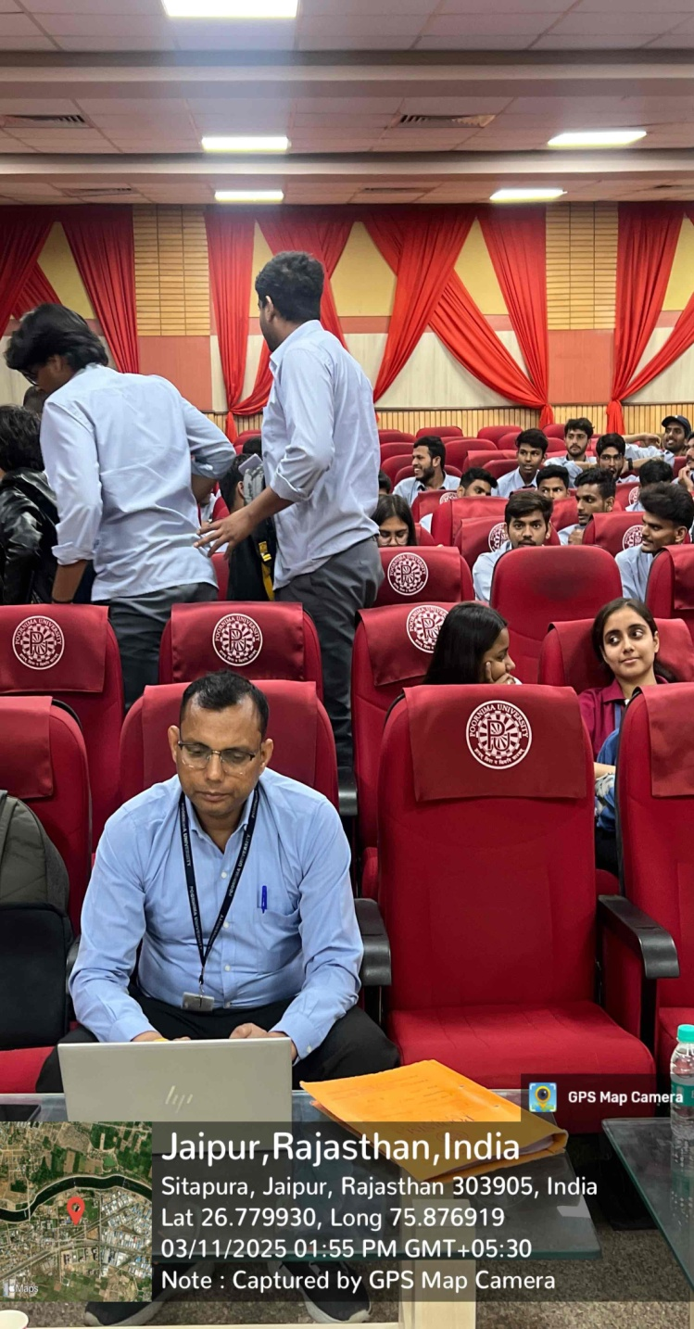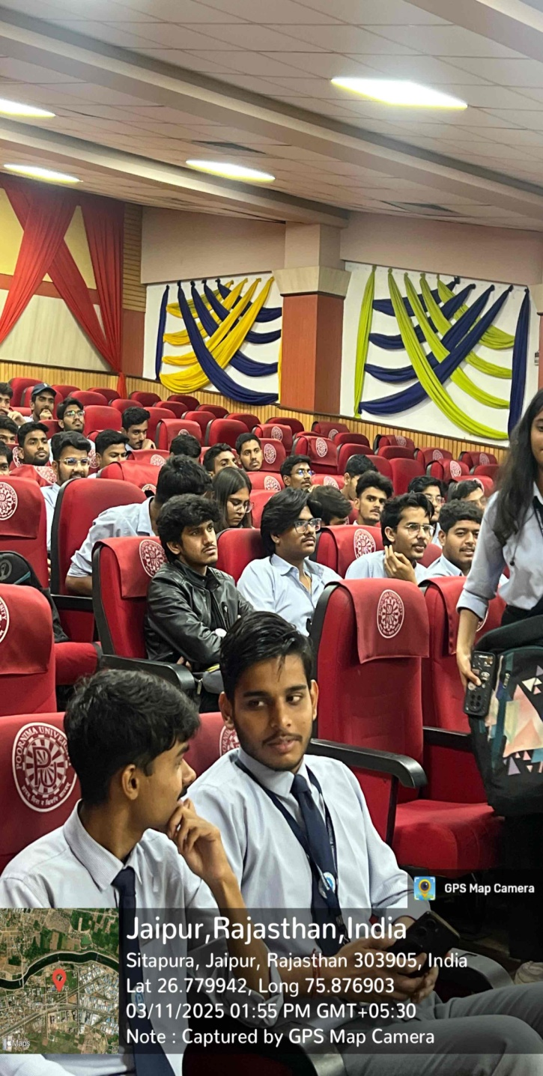

Total number of attendees were 50+.